# CN LAB ASSIGNMENTS

# ASSIGNMENT 1

Q1. Discuss the concept of Networking, advantages, disadvantages and applications.

Ans.

**Computer Network:   
An interconnection of multiple devices, also known as hosts, that are connected using multiple paths for the purpose of sending/receiving data or media. It results in better performance with a high speed of processing.**

**ADVANTAGES OF NETWORK**

**1.Central Storage of Data –**   
Files can be stored on a central node (the file server) that can be shared and made available to each and every user in an organization.

2. **Faster Problem-solving –**   
Since an extensive procedure is disintegrated into a few littler procedures and each is taken care of by all the associated gadgets, an explicit issue can be settled in lesser time.

3.**It is highly flexible –**   
This innovation is known to be truly adaptable, as it offers clients the chance to investigate everything about fundamental things, for example, programming without influencing their usefulness.

**DISADVANTAGES OF NETWORK**

**1.Virus and Malware –**   
On the off chance that even one PC on a system gets contaminated with an infection, there is a possibility for alternate frameworks to get tainted as well. Infections can spread on a system effectively, in view of the availability of different gadgets.

**2 .Cost of the** **network –**   
The expense of executing the system including cabling and equipment can be expensive.

3. **It lacks independence –**   
PC organizing includes a procedure that is worked utilizing PCs, so individuals will depend on a greater amount of PC work, rather than applying an exertion for their jobs that needs to be done. Besides this, they will be subject to the primary document server, which implies that, in the event that it separates, the framework would end up futile, making clients inactive. 

**Applications of computer networks**

**1. Resource Sharing**

  Resource sharing is an application of a computer network. Resource sharing means you can share one Hardware and Software among multiple users. Hardware includes printers, Disks, Fax Machines, etc. Computing devices. And Software includes Atom, Oracle VM Virtual Box, Postman, Android Studio, etc.

**2. Information Sharing**

  Using a Computer network, we can share Information over the network, and it provides Search capabilities such as WWW. Over the network, a single information can be shared among the many users over the internet.

**3. Communication**

  Communication includes email, calls, message broadcast, electronic funds transfer system etc.

**4. Entertainment Industry**

 In Entertainment industry also uses computer networks widely. Some of the Entertainment industries are Video on demand, Multi person real-time simulation.

Q2. Discuss the peer-to-peer connections and multipoint connection.

Ans.

|  |  |  |
| --- | --- | --- |
| **Basis** | **Point-to-Point Connection** | **Multipoint Connection** |
| **Meaning** | A method where two communication devices get connected with each other forming a link between them. | A method where more than two communication devices get linked to each other forming a relationship between them. |
| **Linkage** | A proper link between two devices exists. | Stay connected at all times as they share the connection. |
| **Capacity** | The capacity of the system remains same. | Become shared on a temporary basis. |
| **Objects** | One transmitter and one receiver. | One transmitter and multiple receivers. |
| **Systems** | phone lines, rink line, mobile phone networks, digital cable, radio signals, and fiber optics. | Online working, offices, organizations, shared networks. |
| **Example** | Frame Relay, T-carrier, X.25 | Frame Relay, token ring, Ethernet, ATM. |

Q3. Discuss the components required to make a computer network.

Ans.

Computer networks components comprise both physical parts as well as the software required for installing computer networks, both at organizations and at home. The hardware components are the server, client, peer, transmission medium, and connecting devices. The software components are operating system and protocols.

**Hardware Components**

**Servers** −Servers are high-configuration computers that manage the resources of the network. The network operating system is typically installed in the server and so they give user accesses to the network resources. Servers can be of various kinds: file servers, database servers, print servers etc.

**Clients** − Clients are computers that request and receive service from the servers to access and use the network resources.

**Peers**− Peers are computers that provide as well as receive services from other peers in a workgroup network.

**Transmission Media** − Transmission media are the channels through which data is transferred from one device to another in a network. Transmission media may be guided media like coaxial cable, fibre optic cables etc; or maybe unguided media like microwaves, infra-red waves etc.

**Connecting Devices** − Connecting devices act as middleware between networks or computers, by binding the network media together. Some of the common connecting devices are:

             a. Routers

             b. Bridges

             c. Hubs

             d. Repeaters

             e. Gateways

              f. Switches

**Software Components**

**Networking Operating System** − Network Operating Systems is typically installed in the server and facilitate workstations in a network to share files, database, applications, printers etc.

**Protocol Suite** − A protocol is a rule or guideline followed by each computer for data communication. Protocol suite is a set of related protocols that are laid down for computer networks. The two popular protocol suites are −

a. OSI Model ( Open System Interconnections)

 b. TCP / IP Model

Q4. Discuss the types of networks as LAN, WAN and MAN.

Ans.

|  |  |  |  |
| --- | --- | --- | --- |
| **Basis of Comparison** | **LAN** | **MAN** | **WAN** |
| Full Form | LAN stands for Local Area Network. | MAN stands for Metropolitan Area Network. | WAN stands for Wide Area Network. |
| Definition | It is the type of networking system in which systems are very near to each other. This system is generally in a single office, building or home. | It is a type of networking system in which two or more LANs are communicated. It is located in a vast geographical area. | This networking system has many connections, and these are associated with various companies or organizations at an equivalent time. |
| Ownership of Network | LAN is under the complete control of the owner, i.e., Private. | The ownership of the network can be private or public. | The ownership of the network can be private or public. |
| Speed | Data transmission speed is high. | Data transmission speed is average. | Data transmission speed is low. |
| Maintenance and Design | It can be easy to design and maintain. | It is tough to maintain. | It is tough to maintain. |
| Operational Speed | Its operational speed usually is 10,100 and 1000 Mbps. | Its operational speed usually is 1.5 Mbps, and it may be very at the wireless network. | Its operation is speed usually is 100 Mbps. |
| Fault Tolerance | There is higher fault tolerance in LAN. | There is smaller fault tolerance. | There is smaller fault tolerance. |

Q5. Differentiate between physical and logical topologies.

Ans:

| **Physical Topology** | **Logical Topology** |
| --- | --- |
| Physical Topology means the physical layout of the network. | Logical topology means how the network device layout will be shown and how the data will be transferred. |
| For example − Ring, Bus, Star, and Mesh. | For example − Ring and Bus. |
| In this topology, we are concerned with how data will be transferred from the actual path. | This topology is concerned with the high-level representation of the data transfer. |
| As per the requirement, we can modify the layout of the network. | There is no change accepted. |
| It can affect cost, bandwidth, scalability etc. | It can affect data delivery. |
| Types of physical topologies are star, mesh, bus, and ring. | Types of logical topologies are logical bus, and logical ring. |
| It is an actual route concerned with transmission. | It is a high level representation of data flow. |
| Physical connection of the network. | Data path followed on the network. |

Q6. List the different types of networks from surroundings as client-server network, distributed networks, peer-to-peer networks and cloud based networks.

# Ans: Client and Server model

* A client and server networking model is a model in which computers such as servers provide the network services to the other computers such as clients to perform a user based tasks. This model is known as client-server networking model.
* The application programs using the client-server model should follow the given below strategies:

#### Client and Server model

# Distributed Operating System

A distributed operating system **(DOS)** is an essential type of operating system. Distributed systems use many central processors to serve multiple real-time applications and users. As a result, data processing jobs are distributed between the processors.

It connects multiple computers via a single communication channel. Furthermore, each of these systems has its own processor and memory. Additionally, these **CPUs** communicate via high-speed buses or telephone lines. Individual systems that communicate via a single channel are regarded as a single entity. They're also known as **loosely coupled systems**.

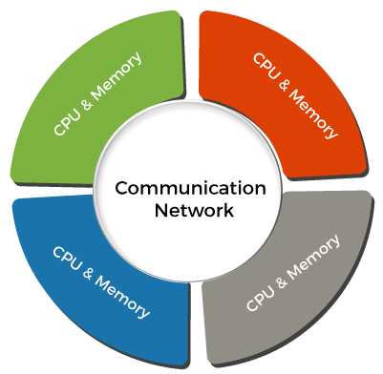

# Computer Network Architecture

Computer Network Architecture is defined as the physical and logical design of the software, hardware, protocols, and media of the transmission of data. Simply we can say that how computers are organized and how tasks are allocated to the computer.

**The two types of network architectures are used:**

* Peer-To-Peer network
* Client/Server network

Q7. Discuss the concept of Network Topologies.

Ans:

A network topology is the physical and logical arrangement of nodes and connections in a network. Nodes usually include devices such as switches, routers and software with switch and router features. Network topologies are often represented as a graph.

Network topologies describe the arrangement of networks and the relative location of traffic flows. Administrators can use network topology diagrams to determine the best placements for each [node](https://www.techtarget.com/searchnetworking/definition/node) and the optimal path for traffic flow. With a well-defined and planned-out network topology, an organization can more easily locate faults and fix issues, improving its data transfer efficiency.

Network geometry can be defined as the physical topology and the logical topology. Network topology diagrams are shown with devices depicted as network nodes and the connections between them as lines. The type of network topology differs depending on how the network needs to be arranged.

Q8. Protocols and their usage e.g. TCP/IP, http, https, ftp.

1. **Transmission Control Protocol (TCP):** TCP is a popular communication protocol which is used for communicating over a network. It divides any message into series of packets that are sent from source to destination and there it gets reassembled at the destination.
2. **Internet Protocol (IP):** IP is designed explicitly as addressing protocol. It is mostly used with TCP. The IP addresses in packets help in routing them through different nodes in a network until it reaches the destination system. TCP/IP is the most popular protocol connecting the networks.
3. **Hyper Text Transfer Protocol (HTTP):** HTTP is designed for transferring a hypertext among two or more systems. HTML tags are used for creating links. These links may be in any form like text or images. HTTP is designed on Client-server principles which allow a client system for establishing a connection with the server machine for making a request. The server acknowledges the request initiated by the client and responds accordingly
4. **Hyper Text Transfer Protocol Secure (HTTPS):** HTTPS is abbreviated as Hyper Text Transfer Protocol Secure is a standard protocol to secure the communication among two computers one using the browser and other fetching data from web server. HTTP is used for transferring data between the client browser (request) and the web server (response) in the hypertext format, same in case of HTTPS except that the transferring of data is done in an encrypted format
5. **File Transfer Protocol (FTP):**FTP allows users to transfer files from one machine to another. Types of files may include program files, multimedia files, text files, and documents, etc.

ASSIGNMENT 2

**Q1.Network interface cards- their use , types and working.**

**Ans.** Network Interface Card (NIC) is a hardware component that is present on the computer. It is used to connect different networking devices such as computers and servers to share data over the connected network. It provides functionality such as support for I/O interrupt, Direct Memory Access (DMA) interfaces, partitioning, and data transmission.

The NIC uses the OSI model to send signals at the physical layer, transmit data packets at the network layer and operate as an interface at the TCP/IP layer.

The network card operates as a middleman between a computer and a data network. For example, when a user requests a webpage, the computer will pass the request to the network card, which converts it into electrical impulses.

A web server on the internet receives the impulses and responds by sending the webpage back to the network card as electrical signals. The card gets these signals and translates them into the data that the computer displays.

**Types of network interface cards**

While the standard NIC is a plastic circuit board that slides into a computer to connect with the motherboard, there are multiple ways this connection can occur:

* **Wireless.** These are NICs that use an antenna to provide wireless reception through radio frequency waves. Wireless NICs are designed for Wi-Fi connections.
* **Wired.** These are NICs that have input jacks made for cables. The most popular wired LAN technology is Ethernet.
* **USB.** These are NICs that provide network connections through a device plugged into the USB port.
* **Fiber optics.** These are expensive and more complex NICs that are used as a high-speed support system for network traffic handling on server computers. This support could also be accomplished by combining multiple NICs.

**Q2. Hub Device and its working.**

**Ans.** Hub is a hardware device used at the physical layer to connect multiple devices in the network. Hubs are widely used to connect LANs. A hub has multiple ports and it is a non-intelligent device.

Unlike a switch, a hub cannot filter the data, i.e. it cannot identify the destination of the packet, so it broadcasts or send the message to each port. This is why it is known as a non-intelligent or dumb device. Hub does not have any routing table to store the data of ports and map destination addresses., the routing table is used to send/broadcast information across all the ports.

A hub is a multiport device, which has multiple ports in a device and shares the data to multiple ports altogether. A hub acts as a dumb switch that does not know, which data needs to be forwarded where so it broadcasts or sends the data to each port. In the hub, data is sent to all ports but each port accepts only that data whose destination address matches their MAC address.

**Q3. Switch Device and its working.**

**Ans.** Switches are networking devices operating at layer 2 or a data link layer of the OSI model. They connect devices in a network and use packet switching to send, receive or forward data packets or data frames over the network.

A switch has many ports, to which computers are plugged in. When a data frame arrives at any port of a network switch, it examines the destination address, performs necessary checks and sends the frame to the corresponding device(s).It supports unicast, multicast as well as broadcast communications.

* A switch operates in the layer 2, i.e. data link layer of the OSI model.
* It is an intelligent network device that can be conceived as a multiport network bridge.
* It uses MAC addresses (addresses of medium access control sublayer) to send data packets to selected destination ports.
* It uses packet switching technique to receive and forward data packets from the source to the destination device.
* It is supports unicast (one-to-one), multicast (one-to-many) and broadcast (one-to-all) communications.
* Transmission mode is full duplex, i.e. communication in the channel occurs in both the directions at the same time. Due to this, collisions do not occur.
* Switches are active devices, equipped with network software and network management capabilities.
* Switches can perform some error checking before forwarding data to the destined port.
* The number of ports is higher – 24/48.

**Q4. Router Device and its working.**

**Ans.** A Router is a networking device that forwards data packets between computer networks. One or more packet-switched networks or subnetworks can be connected using a router. By sending data packets to their intended IP addresses, it manages traffic between different networks and permits several devices to share an Internet connection. Although there are many kinds of routers, the majority of them transfer data between LANs (local area networks) and WANs (wide area networks).

Consider a router as an air traffic controller, and consider data packets as planes flying to various airports (or networks). Each packet must be directed as quickly as possible to its destination, just as each plane has a distinct destination and travels a distinct route. A router assists in guiding data packets to their intended IP address, just like an air traffic controller ensures that aircraft reach their destinations without getting lost or experiencing significant disruptions in a route.

**Q5. Bridge Device and its working.**

**Ans.** A bridge in a computer network is a device used to connect multiple LANs together with a larger Local Area Network (LAN). The mechanism of network aggregation is known as bridging. The bridge is a physical or hardware device but operates at the OSI model’s data link layer and is also known as a layer of two switches.

The primary responsibility of a switch is to examine the incoming traffic and determine whether to filter or forward it. Basically, a bridge in computer networks is used to divide network connections into sections, now each section has separate bandwidth and a separate collision domain. Here bridge is used to improve network performance.

**Uses of Bridge in Computer Network:**

* Bridges are used to increase the network capacity as they can integrate multiple LANs together.
* On receiving a data frame, databases use the bridge to decide whether to accept or reject the data.
* In the OSI model, it can be used to transmit the data to multiple nodes of the network.
* Used to broadcast the data even if the MAC address or destination address is unavailable.
* It forwards data packets despite faulty nodes.
* The data packet can be forwarded or discarded by the bridge when the MAC address is available.

**Ques 6. Types of networking wires and connectors, shapes and specifications.**

Ans. Connectors in networking are just as important as the types of cables that are used to set up computer servers, transfer important data and operate the computer networks that make businesses or homes run.

Types of Connectors

1. Ethernet Cable Connectors

These connectors for twisted-pair Ethernet cables are similar in appearance to a standard telephone cord connector. They are wider, however, because they have eight conductors compared to only four conductors on a telephone jack.

1. Coaxial Cable Connectors

BNC connectors are a type of F-series connectors commonly found in households. They are easy to connect and disconnect from equipment and provide inexpensive, stable connections to these communications devices and other cables.

1. USB Connectors

[USB connectors](https://www.homedepot.com/b/Electrical-Electronics-Cables-USB-Cables/Include-Out-Of-Stock/N-5yc1vZcdszZbwo5s) are the most familiar to the majority of people. USB (Universal Serial Bus) connectors typically join external devices to a personal computer or are used for mobile phone charging. There are adapters that will allow an Ethernet cable to connect directly to a USB port.

1. Fiber Optic Cable Connectors

Fiber optic connectors require different types of connectors from those used with coax or twisted-pair cables, such as CAT5e. These types of connectors in networking must align glass fibers with precision to allow for communication.

The type of wiring connector used depends on the style of jack in the peripheral device.

1. SC connectors: A push-pull latching mechanism in SC connectors provides quick insertion and removal while also ensuring a positive connection.
2. ST connectors: ST connectors were among the first connectors in networking fibre optic cable. These use a plug and socket, which is locked in place with a twist-style bayonet lock.
3. LC connectors: LC-type connectors have a squarish duplex configuration.

**Ques 7. Wireless Access Points.**

Ans. A Wireless Access Point (WAP) is a networking device that allows connecting the devices with the wired network. A Wireless Access Point (WAP) is used to create the WLAN (Wireless Local Area Network), it is commonly used in large offices and buildings which have expanded businesses.

Normally the wireless router allows 10 – 20 users or devices to access the network. While the WAP allows 50 – 100 or more users or devices to access the network.  
The WAP has a stronger ability to send and receives signals which enables high usage.

**Application of Wireless Access Point:**

1. It is a device that creates a WLAN (Wireless Local Area Network) in large enterprises.
2. It is used to extend the coverage area of the network so that it can’t disconnect which allows more users to connect to the network easily.
3. An access point connects a switch, Ethernet cable, wired router, and Wi-fi to designate the particular area.
4. It is used to provide connectivity to the users in large offices or enterprises which allows users to roam easily anywhere in the office and be connected to a network.
5. LANs can also be provided in public places such as coffee shops, restaurants, airports, etc.

**Ques 8. Proxy Servers and usages.**

Ans. Proxy server refers to a server that acts as an intermediary between the request made by clients, and a particular server for some services or requests for some resources. There are different types of proxy servers available that are put into use according to the purpose of a request made by the clients to the servers. The basic purpose of Proxy servers is to protect the direct connection of Internet clients and internet resources.

**Internet Client and Internet resources:**For internet clients, Proxy servers also act as a shield for an internal network against the request coming from a client to access the data stored on the server. It makes the original IP address of the node remains hidden while accessing data from that server.

* **Protects true host identity:**In this method, outgoing traffic appears to come from the proxy server rather than internet navigation. It must be configured to the specific application such as HTTPs or FTP.

**Need Of Private Proxy:**

1. **Defeat Hackers:** To protect organizations data from malicious use, passwords are used and different architects are setup, but still, there may be a possibility that this information can be hacked in case the IP address is accessible easily.
2. **Filtering of Content:**By caching the content of the websites, Proxy helps in fast access to the data that has been accessed very often.
3. **Examine Packet headers and Payloads:**Payloads and packet headers of the requests made by the user nodes in the internal server to access to social websites can be easily tracked and restricted.
4. **To control internet usage of employees and children:**In this, the Proxy server is used to control and monitor how their employees or kids use the internet
5. **Bandwidth savings and improved speeds:**Proxy helps organizations to get better overall network performance with a good proxy server.
6. **Privacy Benefits:**Proxy servers are used to browse the internet more privately. It will change the IP address and identify the information the web request contains.
7. **Security:**Proxy server is used to encrypt your web requests to keep prying eyes from reading your transactions as it provides top-level security.

**Ques 9. Firewall and working principle.**

Ans. A firewall is a network security system designed to prevent unauthorized access to or from a private network. In other words, it prevents unauthorized internet users from accessing private networks connected to the internet, especially intranets.

The implementation must be done in such a way that all incoming/outgoing packets to/from the local network (Intranet) pass through the firewall.

**How Does a Firewall Work?**

Firewalls analyse each block of data packets entering or leaving the Intranet or the host computer. Based on a defined set of security rules, a firewall can perform three actions:

1. **Accept:** allow the transmission of data packets.
2. **Drop:** block data packets with no reply.
3. **Reject:** Block data packets and send “unreachable error” to the source.

ASSIGNMENT 3

**Objective**: To understand some Networking Commands

|  |  |  |  |  |
| --- | --- | --- | --- | --- |
| hostname | ipconfig | getmac | ping | arp |
| nbtstat | route | path | pathping | netstat |
| tracert |  |  |  |  |
|  |  |  |  |  |

**Practice the command mentioned in above table and fill in the blanks below: -**

|  |  |
| --- | --- |
| **Command** | **Working** |

* 1. **ping** command is one of the most often used networking utilities for detecting devices on network and for troubleshooting network problems.

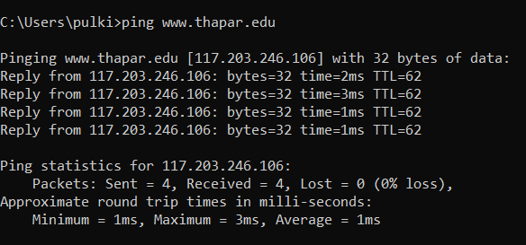

* 1. **hostname** command that displays the host name of your machine



* 1. **ipconfig** frequently used utility that is used for finding network information about your local machine like ip addresses, dns addresses etc.

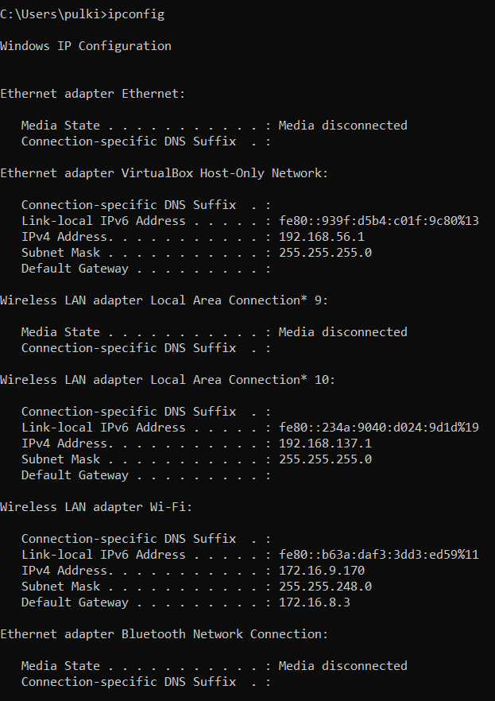

* 1. **nbtstat** diagnostic tool for troubleshooting netbios problems

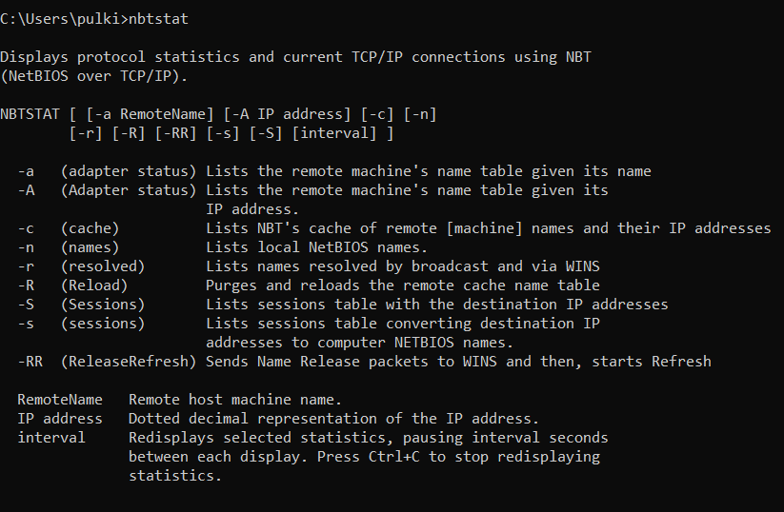

* 1. **netstat** used for displaying information about tcp and udp connections and ports.

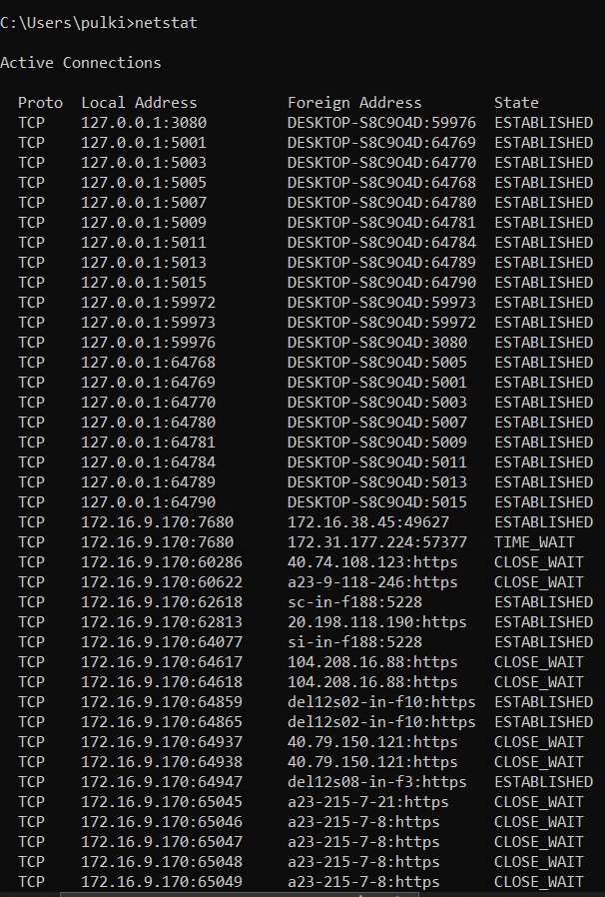

* 1. **getmac** command that shows the mac address of your network interfaces.

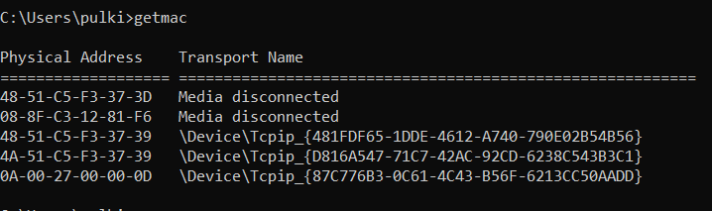

* 1. **arp** for showing the address resolution cache. this command must be used with a command line switch -a is the most common.

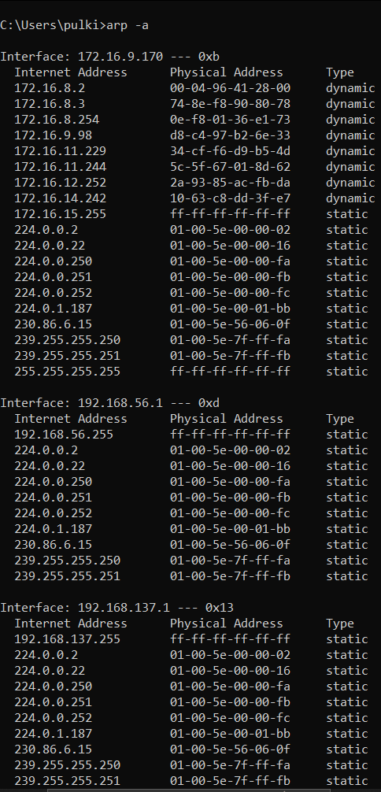

* 1. **tracert** command prints the path. if all routers on the path are functional, this command prints the full path.

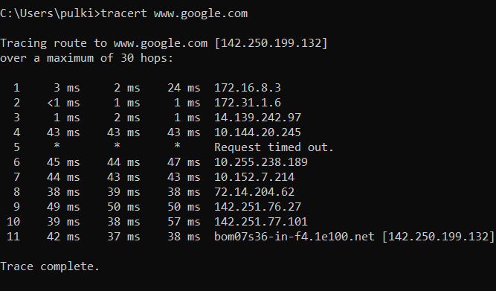

* 1. **path** command specifies the location where ms-dos should look when it executes a command.



* 1. **route** command allows you to make manual entries into the network routing tables.

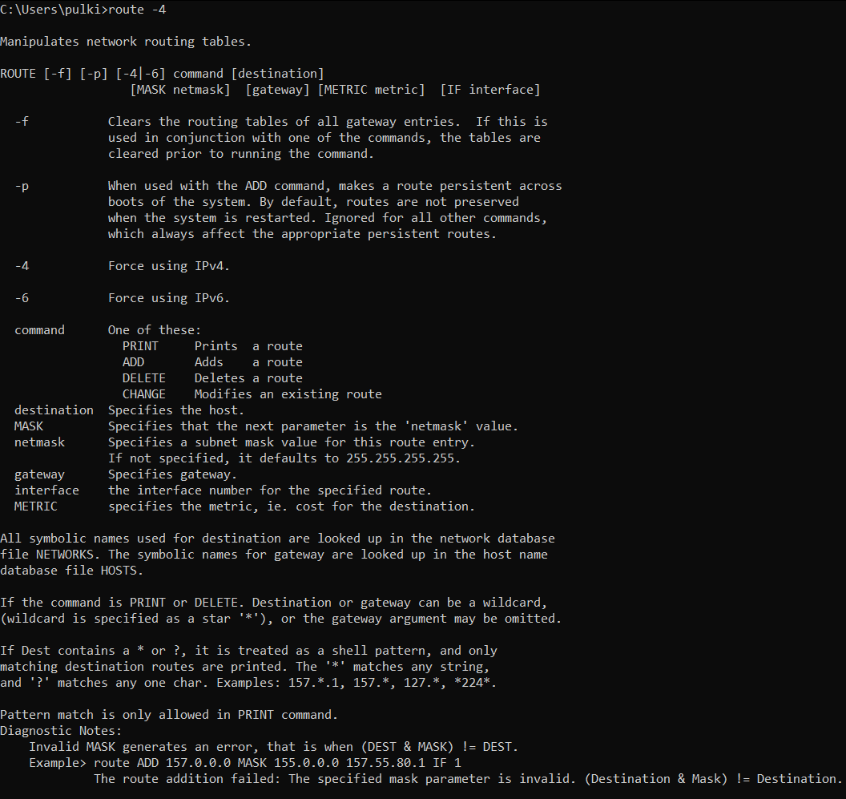

* 1. **pathping** after sending out packets from you to a given destination, it analyzes the route taken and computes packet loss on a per-hop basis.

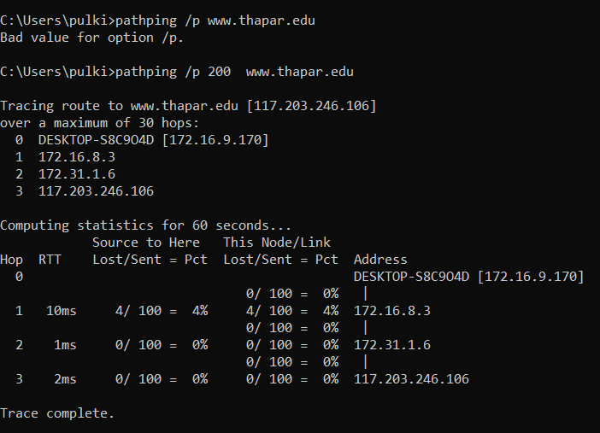

ASSIGNMENT 4

**Q1. Significance of classful addressing (Class- A, B, C, D and E in IP-addressing).**

A1. The first addressing system to be implemented as part of the Internet Protocol was Classful Addressing.

Types of Classful Address-

**Class A, Class B, Class C, Class D, and Class E** are the five varieties of Classful addresses. In IPv4, this classification is known as Classful addressing or IP address classes.

* The first three classes, Class A, B, and C are used for "public addressing", in which communication is always one-to-one between source and destination. It implies that when data is transmitted from a source, it will only be sent to a single network host.
* The reserved categories include Class D and Class E, with Class D being utilized for multicast and Class E being saved for future usage exclusively.
* In IPv4, the Network ID is the first part of Class A, B, and C, while the Host ID is the remaining second portion.
* The Host ID always indicates the number of hosts or nodes in a certain network, whereas the Network ID always identifies the network in a specific place.
* In Class A, B, and C, the address space is split into a certain number of IP address blocks. It also specifies the maximum number of hosts in a network.

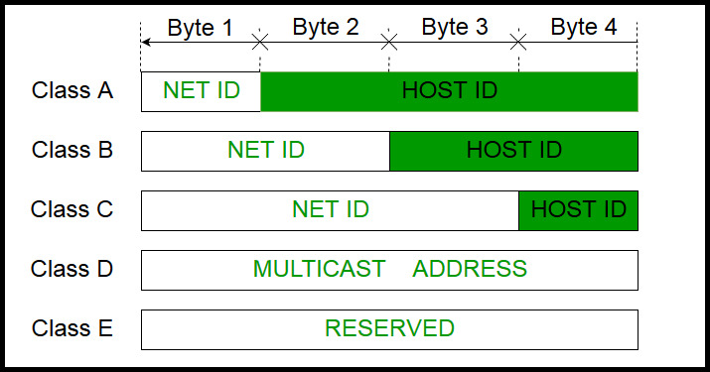

**Q2. Discussion on subnetting and subnet mask.**

A2. **Subnetting** is the process of diving a network into small networks and is a common task on IPV4 networks.

Masking identifies the boundary between the host ID and the combination of net ID and subnet ID.

Each subnet mask comprises 32 bits that correspond to the bits in an IP address. In a subnet mask, the consecutive ones represent the net ID and subnet ID, and consecutive zeros represent the host ID.

Before being subnetted, Class A, B, and C networks use these default masks (also called natural masks): 255.0.0.0, 255.255.0.0, and 255.255.255.0 respectively.

**Q3. Example for Self-Practice:**  
We have a big single network having IP Address 200.1.2.0. We want to do subnetting and divide this network into 4 subnets. Identify following:  
a. IP Address of the subnets   
b. Total number of IP Addresses in each subnet   
c. Total number of hosts that can be configured in each subnet   
d. Range of IP Addresses in each subnet

A3. For creating four subnets and to represent their subnet IDs, we require 2 bits.

So, we borrow two bits from the Host ID part.

After borrowing two bits, Host ID part remains with only 6 bits.

* If borrowed bits = 00, then it represents the 1st subnet.
* If borrowed bits = 01, then it represents the 2nd subnet.
* If borrowed bits = 10, then it represents the 3rd subnet.
* If borrowed bits = 11, then it represents the 4th subnet.

IP Address of the four subnets are-

* 200.1.2.**00**000000 = 200.1.2.0
* 200.1.2.**01**000000 = 200.1.2.64
* 200.1.2.**10**000000 = 200.1.2.128
* 200.1.2.**11**000000 = 200.1.2.192

## **For 1st Subnet-**

* IP Address of the subnet = 200.1.2.0
* Total number of IP Addresses = 26 = 64
* Total number of hosts that can be configured = 64 – 2 = 62
* Range of IP Addresses = [200.1.2.**00**000000, 200.1.2.**00**111111] = [200.1.2.0, 200.1.2.63]

## **For 2nd Subnet-**

* IP Address of the subnet = 200.1.2.64
* Total number of IP Addresses = 26 = 64
* Total number of hosts that can be configured = 64 – 2 = 62
* Range of IP Addresses = [200.1.2.**01**000000, 200.1.2.**01**111111] = [200.1.2.64, 200.1.2.127]

## **For 3rd Subnet-**

* IP Address of the subnet = 200.1.2.128
* Total number of IP Addresses = 26 = 64
* Total number of hosts that can be configured = 64 – 2 = 62
* Range of IP Addresses = [200.1.2.**10**000000, 200.1.2.**10**111111] = [200.1.2.128, 200.1.2.191]

## **For 4th Subnet-**

* IP Address of the subnet = 200.1.2.192
* Total number of IP Addresses = 26 = 64
* Total number of hosts that can be configured = 64 – 2 = 62
* Range of IP Addresses = [200.1.2.**11**000000, 200.1.2.**11**111111] = [200.1.2.192, 200.1.2.255]

**Q4. Discuss the GNS simulation environment.**

A4. **Graphical Network Simulator-3** (shortened to **GNS3**) is a [network](https://en.wikipedia.org/wiki/Computer_network) software [emulator](https://en.wikipedia.org/wiki/Emulator). It allows the combination of virtual and real devices, used to simulate complex networks. GNS3 allows you to run a small topology consisting of only a few devices on your laptop, to those that have many devices hosted on multiple servers or even hosted in the cloud.

GNS3-all-in-one:This is the client part of GNS3 and is graphical user interface (GUI). You install the all-in-one software on your local PC (Windows, MAC, Linux) and create your topologies using this software.

**Q5. Consider the following information Table:**

|  |  |  |
| --- | --- | --- |
| VPCS | PC1 | PC2 |
| IP Address | 192.168.1.1 | 192.168.1.2 |
| Subnet Mask | 255.255.255.0 | 255.255.255.0 |
| Default Gateway | 192.168.1.100 | 192.168.1.100 |
| DNS Server | 192.168.1.100 | 192.168.1.100 |

A5.

ASSIGNMENT 5

Q2. Connect one PC with another PC as per diagram below.

Q3. Connect a PC with Router Ethernet port as shown below.

Q4. Create a network of 2 PCs as below.

Q5. Connect 2 PCs with a Switch below.

Q6. Create BUS topologies as below.



Q7. Create the following Ring Topology



Q8. Create the following Ring Topology.



Q9. Create the following Tree Topology.

